THE RELATIONSHIP BETWEEN MINDLESS SCROLLING ON TIKTOK AND ACADEMIC PROCRASTINATION AMONG 12TH GRADE STUDENTS AT EKAYANA EHIPASSIKO SENIOR HIGH SCHOOL

RESEARCH SCIENTIFIC PAPER

submitted to Ekayana Ehipassiko Senior High School to fulfill the graduation requirements of the Scientific Research Writing Program


Written by:
Livia Margaritta Yapman
0075175531

EKAYANA EHIPASSIKO SENIOR HIGH SCHOOL
SOUTH TANGERANG
2024/2025

VALIDITY SHEET

This work is written by:
name : Livia Margaritta Yapman
NISN : 0075175531
study program : Science
title : The Relationship Between Mindless Scrolling on TikTok and Academic Procrastination Among 12th Grade Students at Ekayana Ehipassiko Senior High School.
has been successfully defended before the Board of Examiners and accepted as part of the Scientific Research Writing Program at Ekayana Ehipassiko Senior High School.
Mentor 1 Mentor 2

(Bhekti Ivan Setyawan, S.S.) (Bernadeta Wiwin Retnaningsih, S.Pd.)

Board of Examiners
Examinator 1 Examinator 2

South Tangerang, 21 February 2025
Principal of Ekayana Ehipassiko Senior High School

(Wiharta Adi Putra, M.I.Kom.)

STATEMENT SHEET

I, the undersigned:
name : Livia Margaritta Yapman
NISN : 0075175531
study program : Science
title : The Relationship Between Mindless Scrolling on TikTok and Academic Procrastination Among 12th Grade Students at Ekayana Ehipassiko Senior High School.
hereby declare that the results of this scientific paper that has been made are my own work and are truly authentic. All reference materials and quotations from this work has been listed in their entirety in references. If in the future, this work is plagiarized or plagiarizes the work of others, then I am willing to be responsible and accept sanctions according to academic regulations at Ekayana Ehipassiko Senior High School.

Thus, I make this statement consciously and without coercion.
Researcher,

Livia Margaritta Yapman

MOTTO

“It’s fine to celebrate success, but it is more important to heed the lessons of failure.”
-Bill Gates-

FOREWORD

Praise and gratitude to God Almighty for His blessings and kindness, which have enabled the researcher to complete this Scientific Paper as one of the graduation requirements from Ekayana Ehipassiko Senior High School. This paper would not have been possible without the support of various individuals. Therefore, the researcher would like to express gratitude to all those who have contributed to the completion of this paper, namely:
- Wiharta Adi Putra, M.I.Kom. as the principal of Ekayana Ehipassiko Senior High School, who has given the opportunity to the researcher to conduct research.
- Bhekti Ivan Setyawan, S.S. as Mentor 1, who has given the time and energy to guide the researcher throughout the process of writing this scientific paper.
- Bernadeta Wiwin Retnaningsih, S.Pd. as Mentor 2 and the English teacher, who has given the time and energy to guide the researcher throughout the process of writing this scientific paper.
- Aurora Eveleen Julia Halim, Freya Lidwina Chandra, and Kegan Tandavo, who have helped tremendously in writing this scientific paper.
- Friends and classmates, who have supported and given advice throughout the process of writing this scientific paper.
- Parents and family members of the researcher, who have supported and given advice throughout the process of writing this scientific paper.
- Everyone who has helped in the process of writing this scientific paper.
This scientific paper is expected to contribute positively to education and society. Despite its shortcomings, the researcher hopes this work becomes the first step for further self-development and greater contributions in the future. In conclusion, the researcher hopes this work will be well-received by everyone and becomes evidence of the researcher’s effort and dedication throughout her time studying in Ekayana Ehipassiko Senior High School.

South Tangerang, 21 February 2025
Researcher

Livia Margaritta Yapman

DEDICATION SHEET

This scientific paper is dedicated to:
- the researcher’s family, thank you for all the kindness, support and love given;
- everyone in Ekayana Ehipassiko School’s community, especially the educators, thank you for the guidance. The education given has become a solid foundation in the researcher’s academic journey;
- Friends and classmates, thank you for the joy, support, and endless inspiration;
- all students of Ekayana Ehipassiko Senior High School, thank you for complying and supporting this scientific paper. The researcher hopes this work will help other students in the process of writing their scientific paper.

In conclusion, the researcher hopes this scientific paper is useful.

ABSTRACT
TikTok is one of the most popular social media platforms whose algorithm for content recommendation encourages prolonged usage, often leading to mindless scrolling. This compulsive content consumption contributes to academic procrastination for students. The present study analyses the relationship between mindless scrolling on TikTok and academic procrastination among 12th grade students at Ekayana Ehipassiko Senior High School. An online survey was distributed to 46 students to collect their responses regarding their mindless scrolling on TikTok, its relationship with academic activities, and their procrastination tendencies. Using a 5-point Likert scale, the data were calculated to reveal the extent of the relationship between the variables. It is concluded that mindless scrolling on TikTok and academic procrastination among 12th grade students at Ekayana Ehipassiko Senior High School has a strong relationship, with an average response value of 3.44. The finding of this study is expected to raise awareness of the harmful effects of mindless scrolling on TikTok towards students' academic performance.
Keywords: mindless scrolling, TikTok, academic procrastination, 12th grade students

ABSTRAK
TikTok adalah salah satu platform media sosial paling populer dengan algoritma rekomendasi konten yang mendorong penggunaan berkepanjangan, yang sering kali mengarah pada mindless scrolling. Konsumsi konten yang kompulsif ini berkontribusi terhadap prokrastinasi akademik di kalangan siswa. Penelitian ini menganalisis hubungan antara mindless scrolling di TikTok dan prokrastinasi akademik pada siswa kelas 12 di SMA Ekayana Ehipassiko. Survei online didistribusikan kepada 46 siswa untuk mengumpulkan respons mereka terkait mindless scrolling di TikTok, hubungannya dengan aktivitas akademik, serta kecenderungan mereka dalam menunda tugas. Data dianalisis menggunakan skala Likert 5 poin untuk mengukur sejauh mana hubungan antara variabel-variabel tersebut. Hasil penelitian menunjukkan bahwa mindless scrolling di TikTok memiliki hubungan yang kuat dengan prokrastinasi akademik pada siswa kelas 12 di SMA Ekayana Ehipassiko, dengan nilai rata-rata respons sebesar 3,44. Temuan ini diharapkan dapat meningkatkan kesadaran akan dampak negatif dari penggunaan TikTok yang berlebihan terhadap performa akademik siswa.
Kata kunci: mindless scrolling, TikTok, prokrastinasi akademik, siswa kelas 12

TABLE OF CONTENTS

VALIDITY SHEET ii
STATEMENT SHEET iv
MOTTO v
FOREWORD vi
DEDICATION SHEET viii
ABSTRACT ix
ABSTRAK x
TABLE OF CONTENTS xi
LIST OF TABLES xii
LIST OF DIAGRAMS xiii
LIST OF CHARTS xiii
CHAPTER I INTRODUCTION xiv
1.1 Background of Study 1
1.2 Problem Formulations 3
1.3 Research Purpose 3
1.4 Research Benefit 4
1.5 Hypothesis 4
1.6 Conceptual Framework 5
CHAPTER II LITERATURE REVIEW 6
2.1 TikTok 6
2.2 Mindless Scrolling 6
2.3 Academic Procrastination 7
2.4 Academic Procrastination and TikTok 8
2.5 Likert Scale 9
CHAPTER III RESEARCH METHODOLOGY 10
3.1 Research Location and Time 10
3.2 Research Design 10
3.3 Operational Definition of Variables 11
3.3.1 Mindless scrolling on TikTok 11
3.3.2 Academic Procrastination 11
3.4 Population and Sample 12
3.5 Research Instrument 12
3.6 Data Collection Technique 15
3.7 Data Analysis Technique 16
CHAPTER IV RESULTS AND DISCUSSION 19
4.1 Survey 19
4.2 Analysis of Overall Responses 20
4.3 Analysis of Section 1 responses 33
4.4 Analysis of Section 2 Response 33
4.5 Analysis of Section 3 Responses 35
CHAPTER V CONCLUSION AND SUGGESTIONS 37
5.1 Conclusion 37
5.2 Suggestions 38
REFERENCES 40

LIST OF TABLES

Table 3.3.1 Research location and time 10
Table 3.5.1 List of questions 15
Table 3.7.1 Table of range and verbal interpretation 18
Table 4.3.1 Average response in section 1 33
Table 4.4.1 Average response in section 2 34
Table 4.5.1 Average response in section 3 35

LIST OF DIAGRAMS

Diagram 4.2.1 Question 2 21
Diagram 4.2.2 Question 3 22
Diagram 4.2.3 Question 4 23
Diagram 4.2.4 Question 5 24
Diagram 4.2.5 Question 6 25
Diagram 4.2.6 Question 7 26
Diagram 4.2.7 Question 8 27
Diagram 4.2.8 Question 9 28
Diagram 4.2.9 Question 10 29
Diagram 4.2.10 Question 11 30
Diagram 4.2.11 Question 12 31
Diagram 4.2.12 Question 13 32

LIST OF CHARTS

Chart 1.6.1 Conceptual framework 5

CHAPTER I
INTRODUCTION

Background of Study
Social media platforms have been growing exponentially in the past two decades. One of the most successful is TikTok. Owned by ByteDance, a technology company based in China, TikTok has become the world's fourth most-used social media platform. The platform hosts videos ranging from three seconds to sixty minutes. The short videos gained TikTok the attention of internet users, especially those with little free time and attention spans. Within less than four years of its release in 2016, TikTok had surpassed two billion mobile downloads worldwide (The Verge, 2020).
According to Ankur (2022), one factor that boosts the popularity of TikTok is its best-in-class AI-based recommendation algorithm. This recommendation system persuades the users to keep watching. A study quoted by Woolley and Sharif in their article published in Harvard Business Review (2022) shows that social media users who have watched five videos on a platform are 10% more likely to watch another one supports the statement. Using TikTok as passive entertainment consumption is also suggested by the contrast between the number of active users and content creators. As of May 2024, TikTok has 1.04 billion monthly active users (eMarketer, 2024), but less than 1% of them are content creators (Social Blade, 2024). This claim is further supported by a study from The Pew Research Centre (2024), which found that nearly half of adult TikTok users never create content for the platform. Being consistently transfixed to an application that proactively offers what is wanted may draw TikTok users into the habit of mindless scrolling.
Birdsong (2020) defined mindless scrolling as a compulsive habit of scrolling without purpose. Around 2015, this term was created to refer to social media users scrolling quickly through content without actually paying attention to it. Baughan et al. (2022) describes it as a “fully absorbing” and “disconnecting” experience. It often leaves disappointment and frustration caused by the feeling of “getting sucked down the rabbit hole” (Baym et al., 2020; Lee et al., 2021).
Mindless scrolling, in other words, imposes an inhibition in a person’s growth. Therefore, it should be a great concern to young generations since according to Charle (2025), about a quarter of TikTok users are teenagers around 10 to 19 years old.
Hunt et al. (2018) mentions that normal social media usage is limited to 30 minutes, yet Common Sense Media (2023) reported that teenagers spend up to 2 hours daily on TikTok, indicating a symptom of addiction. Social media addiction can negatively impact how a young person functions in daily life (Ramsden and Talbot, 2024; Chao et al., 2023; Shannon et al., 2022). Teenagers who spend too much time on social media can experience difficulties in their academic life, including increased procrastination (Nizam et al., 2021). Procrastination is the act of delaying tasks while being aware of the consequences. Meanwhile, academic procrastination refers to the tendency of students to delay completing academic tasks, despite being aware of the deadline (Marcela, 2023).
Some studies have connected TikTok usage and academic procrastination, but they do not specifically relate it with mindless scrolling. Therefore, in this research, the researcher decided to analyze further the relationship of mindless scrolling on TikTok and academic procrastination of 12th grade students, especially those in Ekayana Ehipassiko Senior High School.

Problem Formulations
This research raises the following problems:
- What is the relationship between mindless scrolling on TikTok and academic procrastination of 12th grade students at Ekayana Ehipassiko Senior High School?
- What is the relationship between mindless scrolling on TikTok and academic procrastination related to activities with deadlines of 12th grade students at Ekayana Ehipassiko Senior High School?
- What is the relationship between mindless scrolling on TikTok and academic procrastination related to activities without deadlines of 12th grade students at Ekayana Ehipassiko Senior High School?

Research Purpose
This research is conducted to accomplish the following purposes:
- To describe the relationship between mindless scrolling on TikTok and academic procrastination.
- To define the relationship between mindless scrolling on TikTok and academic procrastination related to activities with deadlines.
- To explicate the relationship between mindless scrolling and academic procrastination related to activities without deadlines.

Research Benefit
This research is hoped to fulfill the following benefits:
            - To raise awareness of the dangers of mindless scrolling on TikTok.
            - As a reference for future papers with similar themes like TikTok, mindless scrolling, and academic procrastination.

Hypothesis
This research has the following hypothesis:
H0: There is a weak relationship between mindless scrolling on TikTok and academic procrastination among 12th grade students in Ekayana Ehipassiko Senior High School.
H1: There is a strong relationship between mindless scrolling on TikTok and academic procrastination among 12th grade students in Ekayana Ehipassiko Senior High School.

Conceptual Framework
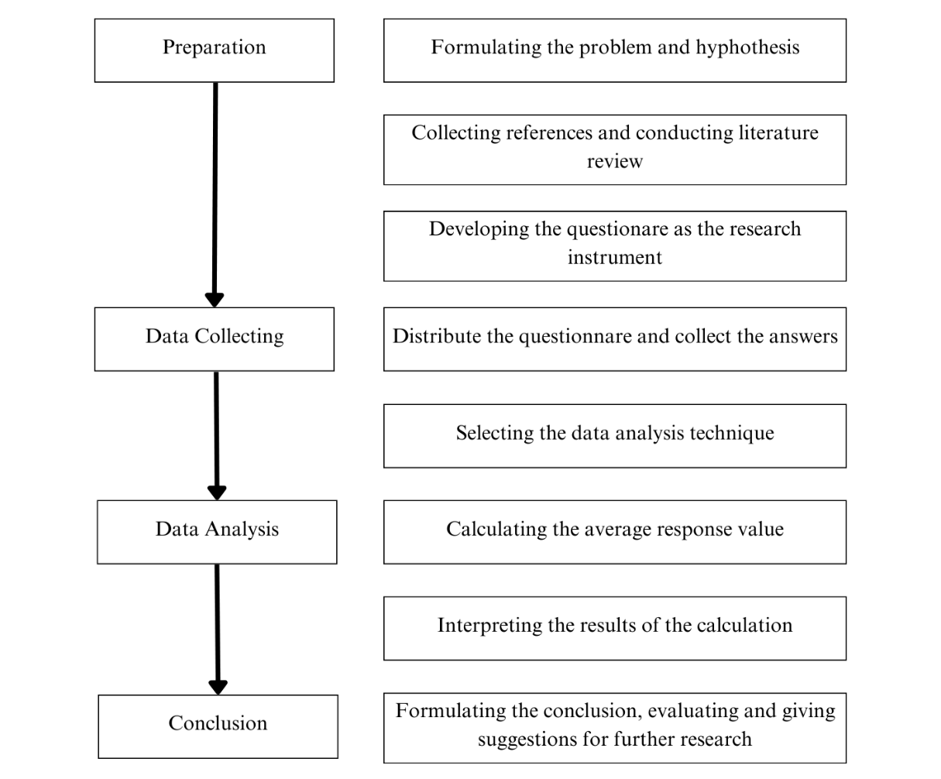

Chart 1.6.1 Conceptual framework

CHAPTER II
LITERATURE REVIEW

2.1 TikTok
TikTok was originally known as Musical.ly or Douyin until it was renamed in 2018. It is a short-video social network application where users can create, edit, and share short videos that are often for entertainment and educational purposes (Regasa and Ettisa, 2023). It became the most widely downloaded mobile app worldwide since its introduction to the international market in 2018, gaining over one billion monthly active users (Cnet, 2022). Irfan Wahyudi (2020) noted that this platform is designed to encourage creativity and allow users to express themselves through short video clips. It is not merely an entertainment platform but has evolved into a lifestyle choice for many users.
Although the app has content for all ages, a quarter of TikTok users are between the ages of 10-19, followed by the age group of 20-29 (Charle, 2025). This makes the app specifically attractive to adolescents, including students, as the majority of the app's content is created by and made for the same demographic (Omar and Dequan, 2020).

Mindless Scrolling
Merriam-Webster (2024) defined mindless as a lack of mind of consciousness. It means requiring little attention or thought and is not intellectually challenging or stimulating. In social media, scrolling is the act of loading new content as the user scrolls down the page. It is often done continuously to kill time (The Hindu, 2023).
Mindless scrolling is a compulsive habit of scrolling without purpose (Birdsong, 2020). This term emerged around 2015 in response to growing concerns over social media users rapidly scrolling through content with seemingly low engagement. It is described as a “dissociative experience” that fully absorbs one in the moment (Baughan et al., 2022). This causes the feeling of being sucked “down the rabbit hole”, which develops regret, disappointment, and frustration (Baym et al., 2020; Lee et al., 2021).
Baughan et al. (2022) noted that he finds himself endlessly scrolling through content without a specific purpose or engagement. He potrays it as a mediative state, though he is unaware his actions. A survey from Unplugged (2024) showed that users waste time by going into a meditative state of scrolling and consuming content. They claim it to be an immediate and gratifying experience. This behavior can trigger dopamine release in the brain, creating a sense of pleasure and reinforcing the habit, similar to addiction.

2.3 Academic Procrastination
Jane B. Burka (Procrastination, 1983: 1) described procrastination as a dandelion. Its roots are deep and it keeps growing back. The origins are inner feelings, fears, hopes, memories, dreams, doubts, and pressures. Procrastination is the act of delaying tasks while being aware of the consequences. It is caused by the inability to manage internal emotions, which often leads to avoiding stressful tasks. The temporary relief this causes builds the habit of procrastination (Sirois, 2022).
Procrastination can vary depending on what type of task is being delayed. This study focuses on academic procrastination, that is defined as a student’s tempting desire to postpone academic activities that may cause anxiety (Gargari et al., 2011). For instance, delaying to study the night before an exam results in stress, haste, and regret. Meanwhile, Marcella (2023) refers to it as the tendency of students to delay completing academic tasks, despite being aware of the deadline. Academic procrastination leads to a decline in students’ well-being. It can cause poor academic performance, emotional distress (stress, anxiety, and depression), as well as physical health deterioration. Onwuegbuzie and Jiao (2000) mentioned that students are more likely to procrastinate tasks such as writing term papers, reviewing for examinations, and weekly reading assignments.

2.4 Academic Procrastination and TikTok
Slimani (2024) found a significant positive correlation between TikTok usage and academic procrastination, supporting the theory that increased engagement with TikTok contributes to higher levels of procrastination among students. This aligns with previous research indicating that the highly stimulating and engaging nature of social media platforms can foster procrastination tendencies (Günlü et al., 2023; Azizi et al., 2019). TikTok, in particular, provides instant gratification and continuous entertainment, which may distract students from their academic responsibilities, ultimately delaying the initiation and completion of academic tasks.

2.5 Likert Scale
The Likert scale is a psychometric tool used in educational and social sciences research to measure 'attitude' in a scientifically accepted and validated manner. It consists of a set of statements (items) related to situation, and participants indicate their level of agreement (from strongly disagree to strongly agree) on a metric scale. The statements are inter-linked and reveal a specific dimension of attitude towards the issue (Joshi et al., 2015).
The 5-point Likert scale is one of the variations where respondents choose from five options, typically ranging from "strongly disagree" to "strongly agree," with a neutral point in the middle (Joshi et al., 2015).

CHAPTER III
RESEARCH METHODOLOGY

3.1 Research Location and Time
This research is done in Ekayana Ehipassiko Senior High School, with details shown below:
Date | Activity
Thursday, 1 August 2024 | Approval of Title
Tuesday, 30 July 2024 | Writing Chapter I
Jumat, 30 Agustus 2024 | Writing Chapter II
Friday, 1 November 2024 | Writing Chapter III
Thursday, 10 October 2024 | Survey Distribution
Saturday, 1 February 2025 | Writing Chapter IV
Monday, 10 February 2025 | Writing Chapter V

Table 3.1.1 Research location and time

3.2 Research Design
The design used for this study is descriptive study. In descriptive study, the researcher describes groups, activities, situations, or events, with a focus on structure, attitudes, or behavior. Quantitative data analysis, or analysis based on the statistical summary of data is frequently used in this type of study. The topic is by the researcher before data is collected, so the intended outcome is a relatively accurate and precise. (Adler and Clark, An Invitation to Social Research, 2011: 14-15).
The present study explores two types of academic procrastination: procrastination related to activities with deadlines and activities without deadlines. Academic procrastination related to activities with deadlines includes activities such as completing homework and writing essays, where there is a clearly defined due date. The latter includes activities like studying, reviewing material, and discussing with teachers or classmates, and tasks that have flexible goals and no specific time constraints.

3.3 Operational Definition of Variables

3.3.1 Mindless scrolling on TikTok
Mindless scrolling is a compulsive habit of continuously scrolling through content without a clear purpose or engagement. It is described as a dissociative experience that fully absorbs users, often leading to regret and frustration. This behavior triggers dopamine release in the brain, reinforcing the habit in a way similar to addiction.

3.3.2 Academic Procrastination
Academic procrastination is the tendency of students to delay academic tasks despite being aware of deadlines, often leading to anxiety and stress. It can negatively impact students' well-being, causing poor academic performance, emotional distress, and even physical health issues. Commonly procrastinated tasks include writing papers, studying for exams, and completing reading assignments.

3.4 Population and Sample
According to Lind et al. (2017), population is the number of people or things that share a particular attribute. Meanwhile, Supardi (1993) defined it as a group of individuals or subjects in an environment and time with a certain quality that will be analyzed. In conclusion, a population is a group of people with a similar trait that will be observed. One of the constituents of the population is a sample. Etikan et al. (2016) stated that a sample is a part of the entire population. The population observed in this research is students of Ekayana Ehipassiko Senior High School, with the sample being 46 students from Grade 12.

3.5 Research Instrument
To conduct this study, the researcher uses a survey consisting of 13 questions, divided into three topics. A survey is a method to collect information from a sample of individuals (Scheuer, 1980). The type of survey used is the Guided Response, which is recall-type questions in multiple-choice form (Columbia University, 2022). The survey uses a 5-point Likert scale to assess responses to positive and negative statements. Below is the list of questions in the survey.
No. | Questions
1. | Do you use TikTok?  Apakah Anda menggunakan TikTok?

No. | Section 1: Questions about TikTok and mindless scrolling in TikTok
1. | How long do you usually scroll on TikTok?  Seberapa lama Anda biasa scrolling di TikTok?
2. | I can keep scrolling in TikTok without a certain purpose.  Saya dapat terus scrolling di TikTok tanpa tujuan tertentu.
3. | I can lose track of time while scrolling in TikTok.  Saya dapat lupa waktu saat sedang scrolling di TikTok.

No. | Section 2: Questions about the effect of mindless scrolling in TikTok towards academic procrastination related to activities with deadlines
1. | I procrastinate on doing my school assignments despite knowing the risk is submitting them late.  Saya menunda mengerjakan tugas sekolah meskipun saya tahu resikonya adalah terlambat mengumpulkan.
2. | I take the time to scroll in TikTok while doing my school assignments.  Saya menyempatkan diri scrolling di TikTok saat sedang mengerjakan tugas sekolah.
3. | Scrolling in TikTok causes me to procrastinate on completing school assignments.  Scrolling di TikTok menyebabkan saya menunda penyelesaian tugas sekolah.
4. | School assignments will finish faster if I don’t interrupt it with scrolling in TikTok.  Tugas sekolah akan lebih cepat selesai jika saya tidak menginterupsinya dengan scrolling di TikTok.
5. | I find it hard to resist scrolling in TikTok while doing school assignments.  Saya sulit menahan diri dari scrolling di Tiktok saat sedang mengerjakan tugas sekolah.

No. | Section 3: Questions about the effect of mindless scrolling in TikTok towards academic procrastination related to activities without deadlines
1. | I procrastinate my study activities outside of school.  Saya menunda kegiatan belajar saya di luar sekolah.
2. | I take the time to scroll in TikTok while studying.  Saya menyempatkan diri scrolling di TikTok saat sedang mengerjakan tugas sekolah.
3. | Studying will be more effective if I don’t interrupt it with scrolling in TikTok.  Kegiatan belajar akan lebih efektif jika saya tidak menginterupsinya dengan scrolling di Tiktok.
4. | I find it hard to resist scrolling in TikTok while studying outside of school.  Saya sulit menahan diri dari scrolling di Tiktok saat sedang belajar di luar sekolah.

Table 3.5.1 List of questions

3.6 Data Collection Technique
In collecting research data, the researcher used an online survey conducted via Google Forms to see the responses of 46 students about the relationship between mindless scrolling on TikTok and academic procrastination of 12th grade students at Ekayana Ehipassiko Senior High School. The survey is then distributed through WhatsApp.

3.7 Data Analysis Technique
To calculate the value of average responses, this study uses the 5-point Likert Scale. A numerical value from 1 to 5 is assigned to the options. There are three types of options: duration, agreement level, and frequency.
The value of each option regarding duration are shown below:
- More than 120 minutes (Lebih dari 120 menit): 5 points
- 90 to 120 minutes (90 sampai 120 menit): 4 points
- 60 to 90 minutes (60 sampai 90 menit): 3 points
- 30 to 60 minutes (30 sampai 60 menit): 2 points
- Less than 30 minutes (Kurang dari 30 menit): 1 point
The value of each option regarding agreement level are shown below:
- Strongly agree (Sangat setuju): 5 points
- Agree (Setuju): 4 points
- Neutral (Netral): 3 points
- Disagree (Tidak setuju): 2 points
- Strongly disagree (Sangat tidak setuju ): 1 point
The value of each option regarding frequency are shown below:
- Always (Selalu): 5 points
- Often (Sering): 4 points
- Sometimes (Kadang-kadang): 3 points
- Rarely (Jarang): 2 points
- Never (Tidak pernah): 1 point
The researcher then calculates the average value of the responses. The formula is shown below:
$$Average value of responses=\frac{Σ Value of responses}{Number of respondents ×Number of questions}$$

To determine the ranges for verbal interpretation, the difference between the highest and lowest points on the Likert Scale is calculated and then divided by the total number of points. This results in an interval of 0.80. Each subsequent range is then incremented by this interval to create the brackets for interpretation. Finally, the average value of the responses is compared to the corresponding ranges on the Likert Scale table to determine the appropriate verbal interpretation (Lai, 2020). The calculation is shown below:
$$Interval= \frac{Highest point-Lowest point}{Number of points}$$
$$= \frac{5-1}{5}=0.80$$
$$Range=Point+0.80$$

The table of range and verbal interpretation is shown in the next page.

Point | Range | Verbal Interpretation
5 | 4.21 – 5.00 | Very Strong
4 | 3.41 – 4.20 | Strong
3 | 2.61 – 3.40 | Moderately Strong
2 | 1.81 – 2.60 | Weak
1 | 1.00 – 1.80 | Very Weak

Table 3.7.1 Range and verbal interpretation

CHAPTER IV
RESULTS AND DISCUSSION

4.1 Survey
The study involved 46 participants from Grade 12 at Ekayana Ehipassiko Senior High School. Data were collected through a 5-point Likert scale survey comprising 13 questions. The survey is divided into three main sections:
- TikTok and mindless scrolling, consisting of question 2 to 4
- the relationship between mindless scrolling in TikTok and academic procrastination related to activities with deadlines, consisting of question 5 to 9
- the relationship between mindless scrolling on TikTok and academic procrastination related to activities without deadlines, consisting of question 9 to 13
The average response value for each section is then calculated, categorized, and organized in tables. This allows for comparisons between topics and determines their verbal interpretations. The first question about whether the respondent uses TikTok is excluded from all calculations.
The survey is conducted online via Google Forms. The link is then distributed through WhatsApp. The survey collected 46 responses which are recorded on a spreadsheet. 7 respondents who don’t use TikTok are excluded from calculations.

4.2 Analysis of Overall Responses
The average value of responses of 39 respondents is shown in the calculation below.
$$Average value of response= \frac{1535}{39×12}=3.28$$

By comparing the calculated results with Table 3.7.1, the average value of 3.28 is classified as moderately strong, meaning there is a moderately strong relationship between mindless scrolling on TikTok and academic procrastination among 12th grade students at Ekayana Ehipassiko School.

The distribution of the responses for the question “How long do you usually scroll on TikTok?” is shown in the pie chart below.

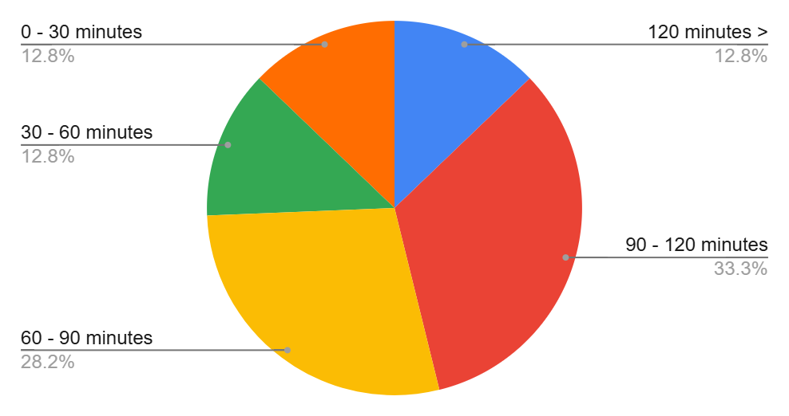

Diagram 4.2.1 Question 2

The analysis shows that among the 12th grade students of Ekayana Ehipassiko Senior High School, 5 students (12.8%) usually scroll on TikTok for more than 2 hours, 13 students (33.3%) usually scroll on TikTok for 90 to 120 minutes, 11 students (28.2%) usually scroll on TikTok for 60 to 90 minutes, 5 students (12.8%) usually scroll on TikTok for 30 to 60 minutes, and 5 students (12.8%) usually scroll on TikTok for less than 30 minutes. Based on this, it can be concluded that the majority of 12th grade students at Ekayana Ehipassiko Senior High School often scroll on TikTok for more than 30 minutes, with 29 students (74.3%) agreeing.

Next, the following pie chart visualizes the responses to the statement “I can keep scrolling in TikTok without a certain purpose”.

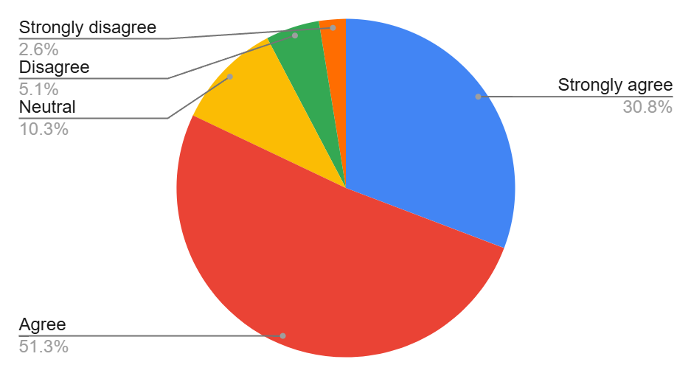

Diagram 4.2.2 Question 3

The analysis shows that among the 12th grade students of Ekayana Ehipassiko Senior High School, 12 students (30.8%) strongly agree, 20 students (51.3%) agree, 4 students (10.3%) are neutral about the statement, 2 students (5.1%) disagree, and 1 student (2.6%) strongly disagree. Based on this, it can be concluded that the majority of 12th grade students at Ekayana Ehipassiko Senior High School BSD agree with this statement, with 32 students (82.1%) expressing agreement.

Then, the pie chart below presents the answers to the question “I can lose track of time while scrolling in TikTok”.

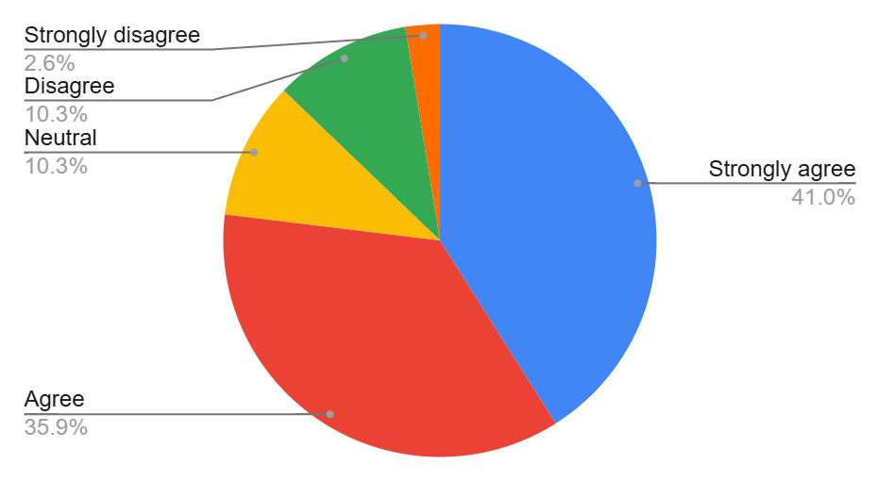

Diagram 4.2.3 Question 4

The analysis shows that among the 12th grade students of Ekayana Ehipassiko Senior High School, 16 students (41%) strongly agree, 14 students (35.9%) agree, 4 students (10.3%) are neutral about the statement, 4 students (10.3%) disagree, and 1 student (2.6%) strongly disagree. Based on this, it can be concluded that the majority of 12th grade students at Ekayana Ehipassiko Senior High School BSD agree with this statement, with 30 students (76.9%) expressing agreement.

The following pie chart presents how respondents answered the statement “I procrastinate on doing my school assignments despite knowing the risk is submitting them late”.

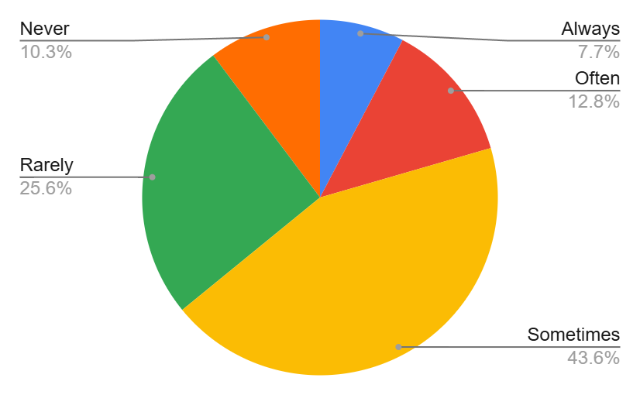

Diagram 4.2.4 Question 5

The analysis shows that among the 12th grade students of Ekayana Ehipassiko Senior High School, 3 students (7.7%) always do it, 5 students (12.8%) often do it, 17 students (43.6%) sometimes do it, 10 students (25.6%) rarely do it, and 4 students (10.3%) never do it. Based on this, it can be concluded that the majority of 12th grade students at Ekayana Ehipassiko Senior High School BSD sometimes do the activity described in the statement, with 17 students (43.6%) expressing agreement.

The pie chart below shows the responses to the statement “I take the time to scroll in TikTok while doing my school assignments”.

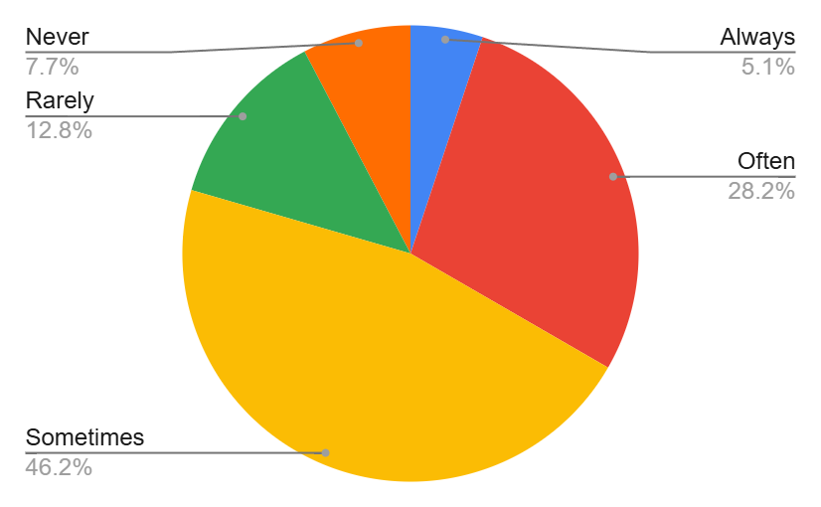

Diagram 4.2.5 Question 6

The analysis shows that among the 12th grade students of Ekayana Ehipassiko Senior High School, 2 students (5.1%) always do it, 11 students (28.2%) often do it, 18 students (46.2%) sometimes do it, 5 students (12.8%) rarely do it, and 3 students (7.7%) never. Based on this, it can be concluded that the majority of 12th grade students at Ekayana Ehipassiko Senior High School BSD sometimes do the activity described in the statement, with 18 students (46.2%) expressing agreement.

The pie chart below visualizes the answers to the statement “Scrolling in TikTok causes me to procrastinate on completing school assignments”.

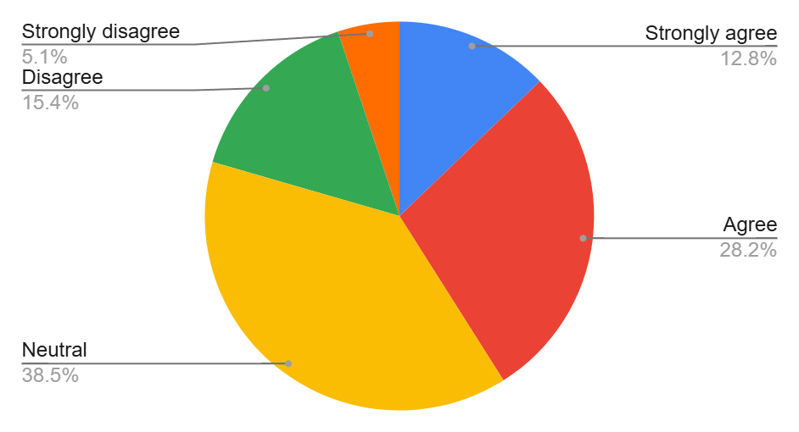

Diagram 4.2.6 Question 7

The analysis shows that among the 12th grade students of Ekayana Ehipassiko Senior High School, 5 students (12.8%) strongly agree, 11 students (28.2%) agree, 15 students (38.5%) are neutral about the statement, 6 students (15.4%) disagree, and 2 students (5.1%) strongly disagree. Based on this, it can be concluded that the majority of 12th grade students at Ekayana Ehipassiko Senior High School BSD agree with this statement, with 16 students (41%) expressing agreement.

Next, the responses to the statement "School assignments will finish faster if I don’t interrupt it with scrolling in TikTok" are represented in the pie chart below.

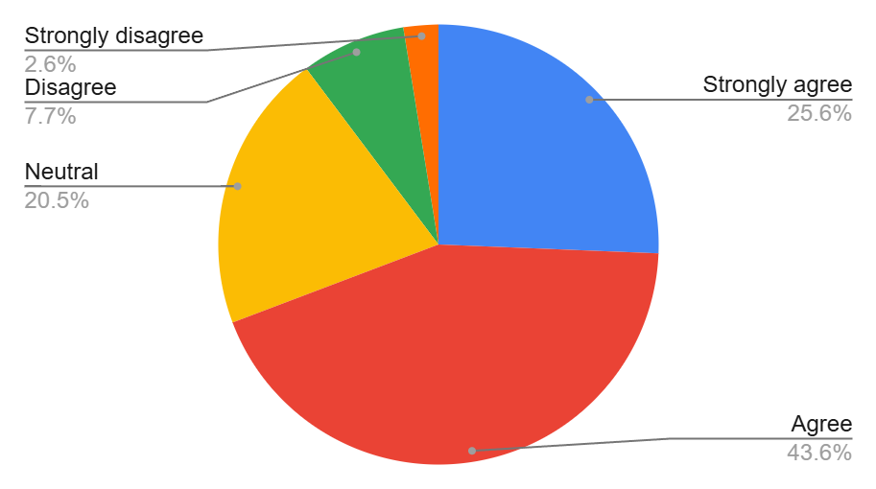

Diagram 4.2.7 Question 8

The analysis shows that among the 12th grade students of Ekayana Ehipassiko Senior High School, 10 students (25.6%) strongly agree, 17 students (43.6%) agree, 8 students (20.5%) are neutral about the statement, 3 students (7.7%) disagree, and 1 student (2.6%) strongly disagree. Based on this, it can be concluded that the majority of 12th grade students at Ekayana Ehipassiko Senior High School BSD agree with this statement, with 16 students (41%) expressing agreement.

The following pie chart displays the answers to the question "I find it hard to resist scrolling in TikTok while doing school assignments”.

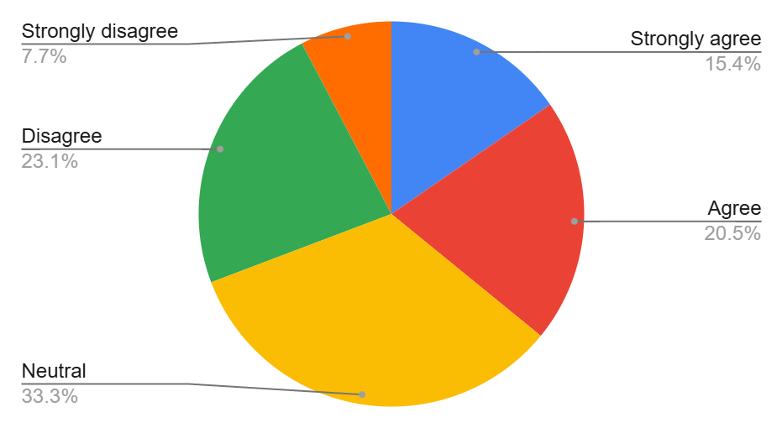

Diagram 4.2.8 Question 9

The analysis shows that among the 12th grade students of Ekayana Ehipassiko Senior High School, 6 students (15.4%) strongly agree, 8 students (20.5%) agree, 13 students (33.3%) are neutral about the statement, 9 students (23.1%) disagree, and 3 students (7.7%) strongly disagree. Based on this, it can be concluded that the majority of 12th grade students at Ekayana Ehipassiko Senior High School BSD agree with this statement, with 14 students (35.9%) expressing agreement.

The responses to the statement "I procrastinate my study activities outside of school" are represented in the pie chart below.

Diagram 4.2.9 Question 10

The analysis shows that among the 12th grade students of Ekayana Ehipassiko Senior High School, 3 students (7.7%) always do it, 11 students (28.2%) often do it, 18 students (46.2%) sometimes do it, 4 students (10.3%) rarely do it, and 3 students (7.7%) never do it. Based on this, it can be concluded that the majority of 12th grade students at Ekayana Ehipassiko Senior High School BSD sometimes do the activity described in the statement, with 18 students (46.2%) expressing agreement.

The distribution of the responses for the for the question “I take the time to scroll in TikTok while studying” is shown in the pie chart below.

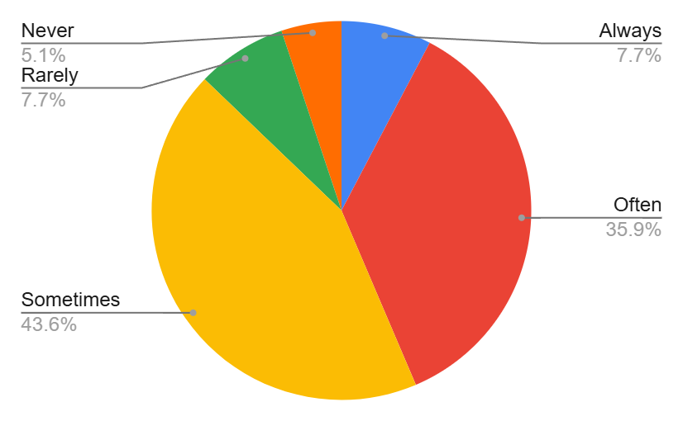

Diagram 4.2.10 Question 11

The analysis shows that among the 12th grade students of Ekayana Ehipassiko Senior High School, 3 students (7.7%) always do it, 14 students (35.9%) often do it, 17 students (43.6%) sometimes do it, 3 students (7.7%) rarely do it, and 2 students (5.1%) never do it. Based on this, it can be concluded that the majority of 12th grade students at Ekayana Ehipassiko Senior High School BSD often and sometimes do the activity described in the statement, with 34 students (43.6%) expressing agreement.

The pie chart below visualizes the responses to the statement “Studying will be more effective if I don’t interrupt it with scrolling in TikTok”.

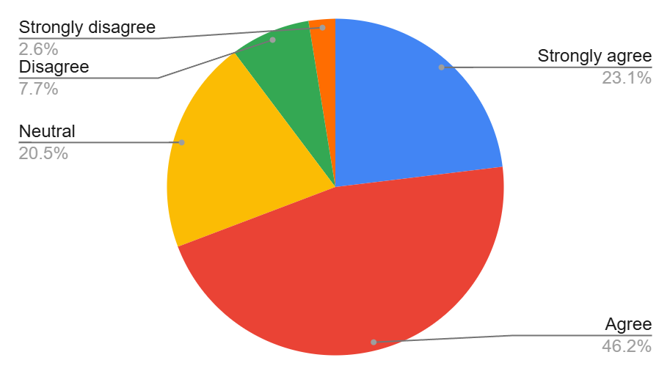

Diagram 4.2.11 Question 12

The analysis shows that among the 12th grade students of Ekayana Ehipassiko Senior High School, 9 students (23.1%) strongly agree, 18 students (46.2%) agree, 8 students (20.5%) are neutral about the statement, 3 students (7.7%) disagree, and 1 student (2.6%) strongly disagree. Based on this, it can be concluded that the majority of 12th grade students at Ekayana Ehipassiko Senior High School BSD agree with this statement, with 27 students (69.3%) expressing agreement.
Lastly, the responses to the statement “I find it hard to resist scrolling in TikTok while studying outside of school” are represented in the chart below.

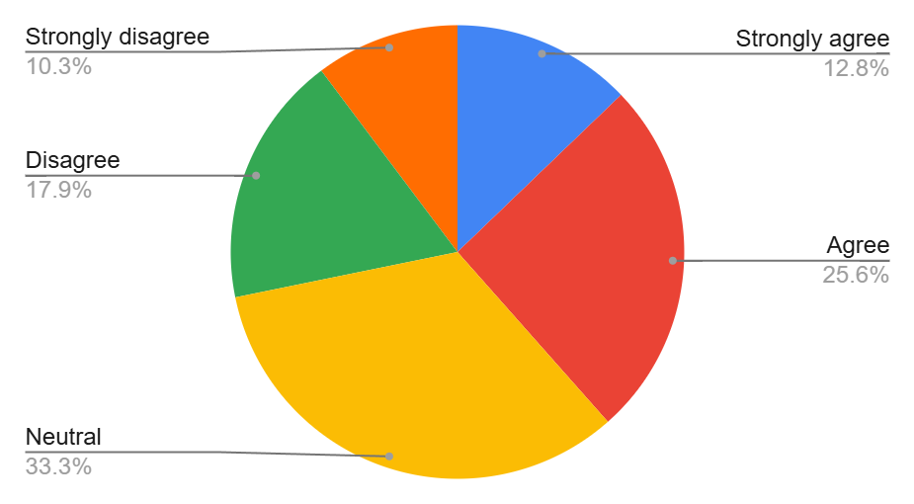

Diagram 4.2.12 Question 13

The analysis shows that among the 12th grade students of Ekayana Ehipassiko Senior High School, 5 students (12.8%) strongly agree, 10 students (25.6%) agree, 13 students (33.3%) are neutral about the statement, 7 students (17.9%) disagree, and 4 student (10.3%) strongly disagree. Based on this, it can be concluded that the majority of 12th grade students at Ekayana Ehipassiko Senior High School BSD agree with this statement, with 15 students (38.4%) expressing agreement.

Analysis of Section 1 Responses
Section 1 consists of question 2 to 4, which discuss the relationship between the respondent, TikTok and mindless scrolling on TikTok. The responses are sorted by question. The average response for each question is calculated, then summed to determine the overall section average.
No. | Questions | Average response | Average response by section
1 | Question 2 | 3.21 | 3.74
2 | Question 3 | 4.00 | 3.74
3 | Question 4 | 4.00 | 3.74

Table 4.3.1 Average response in section 1

By comparing the calculated results with Table 3.7.1, the average value of 3.74 is interpreted as strong. This indicates a strong relationship between TikTok, mindless scrolling on TikTok and the 12th grade students in Ekayana Ehipassiko Senior High School. Therefore, it can be concluded that the 12th grade students in Ekayana Ehipassiko Senior High School often do mindless scrolling on TikTok.

Analysis of Section 2 Responses
Section 1 consists of question 5 to 9, which discuss the relationship between mindless scrolling on TikTok and academic procrastination related to activities with deadlines. The responses are sorted by question. The average response for each question is calculated, then summed to determine the overall section average.
No. | Questions | Average Response | Average response by section
1 | Question 5 | 2.76 | 3.18
2 | Question 6 | 3.05 | 3.18
3 | Question 7 | 3.24 | 3.18
4 | Question 8 | 3.79 | 3.18
5 | Question 9 | 3.08 | 3.18

Table 4.4.1 Average response in section 2

By comparing the calculated results with Table 3.7.1, the average value of 3.18 is interpreted as moderately strong. This indicates a moderately strong relationship between mindless scrolling on TikTok, academic procrastination related to activities with deadlines and the 12th grade students in Ekayana Ehipassiko Senior High School. Therefore, it can be concluded that mindless scrolling on TikTok contributes to academic procrastination related to activities with deadlines among the 12th grade students in Ekayana Ehipassiko Senior High School.

Analysis of Section 3 Responses
Section 1 consists of question 5 to 9, which discuss the relationship between mindless scrolling on TikTok and academic procrastination related to activities without deadlines. The responses are sorted by question. The average response for each question is calculated, and then summed to determine the overall section average.
No. | Questions | Average Response | Average response by section
1 | Question 10 | 3.13 | 3.32
2 | Question 11 | 3.29 | 3.32
3 | Question 12 | 3.76 | 3.32
4 | Question 13 | 3.08 | 3.32

Table 4.5.1 Average response in section 3

By comparing the calculated results with Table 3.7.1, the average value of 3.32 is interpreted as moderately high. This indicates a moderately strong relationship between mindless scrolling on TikTok, academic procrastination related to activities without deadlines and the 12th grade students in Ekayana Ehipassiko Senior High School. Therefore, it can be concluded that mindless scrolling on TikTok contributes to academic procrastination related to activities without deadlines among the 12th grade students in Ekayana Ehipassiko Senior High School.

CHAPTER V
CONCLUSION AND SUGGESTIONS

5.1 Conclusion
From the study, it is obtained an average response value of 3.28. After comparing the number with Table 3.7.1, it is concluded that the relationship between mindless scrolling on TikTok and academic procrastination among 12th grade students in Ekayana Ehipassiko Senior High School is moderately strong. This means that the more frequently students engage in mindless scrolling on TikTok, the more likely they procrastinate in academic activities.
Moreover, the relationship between mindless scrolling on TikTok and both academic procrastination related to activities with deadlines and activities without deadlines among 12th grade students in Ekayana Ehipassiko Senior High School are moderately strong, with the average response values of 3.18 and 3.32. It can be concluded that the more frequently students engage in mindless scrolling on TikTok, the more likely they procrastinate in academic activities, with or without deadlines.
This study has the following hypothesis:
H0: There is a weak relationship between mindless scrolling on TikTok and academic procrastination among 12th grade students in Ekayana Ehipassiko Senior High School.
H1: There is a strong relationship between mindless scrolling on TikTok and academic procrastination among 12th grade students in Ekayana Ehipassiko Senior High School.
Therefore, hypothesis 1 aligns with this study’s findings as the average value of response being 3.28 indicates a moderately strong relationship.

Suggestions
Several aspects of this study can be further improved. The researcher has the following suggestions:
            - Longitudinal research, where the level of academic procrastination is measured periodically and continuously. For instance, the research is done towards 11th grade students and is repeated when they progress to 12th grade.
            - Grouping academic procrastination by lessons in school, which will narrow down the study and consider other factors. For example, a student might procrastinate doing assignments in mathematics, but not in science. The reason behind it might involve other factors, such as lack of understanding.
            - Expanding the sample to include all high school students at Ekayana Ehipassiko Senior High School could strengthen the validity of this study
The researcher hopes that this study can raise awareness of the dangers of mindless scrolling on TikTok towards students’ academic performance. Furthermore, this study is expected to become a reference for future research that seeks to explore this topic or similar themes in greater depth.

REFERENCES

Goodman, L. 2020. TikTok app download numbers update: 2 billion users. The Verge. Retrieved September 15, 2024. https://www.theverge.com/2020/4/29/21241788/tiktok-app-download-numbers-update-2-billion-users

Alter, A. L. 2022. The psychology of your scrolling addiction. Harvard Business Review. Retrieved September 15, 2024. https://hbr.org/2022/01/the-psychology-of-your-scrolling-addiction

Backlinko Team. 2024. TikTok users. Backlinko. Retrieved September 15, 2024. https://backlinko.com/tiktok-users
Ground, B. 2024. TikTok creator stats. Exploding Topics. Retrieved September 15, 2024. https://explodingtopics.com/blog/tiktok-creator-stats

Vogels, E. A. 2024. How U.S. adults use TikTok. Pew Research Center: Internet & Technology. Retrieved September 15, 2024. https://www.pewresearch.org/internet/2024/02/22/how-u-s-adults-use-tiktok/

Khan, S., et al. 2023. “Scrolling mindlessly: Emerging mental health concerns related to social media use during adolescence”. Journal of Pediatric Health Care, 37(2), 225-232. Retrieved September 15, 2024. https://journals.lww.com/jphp/fulltext/2023/04030/scrolling_mindlessly__emerging_mental_health.15.aspx

Reer, F., & Quandt, T. 2024. Studying TikTok: Challenges of researching a black box. Journal of Computer-Mediated Communication, 29(1), zmad056. Retrieved September 15, 2024. https://doi.org/10.1093/jcmc/zmad056

Shah, N. 2024. TikTok statistics. Wallaroo Media. Retrieved September 15, 2024. https://wallaroomedia.com/blog/social-media/tiktok-statistics/

Sbarra, D. A., Smith, H. L., & মেহবুব, S. 2018. “When Social Media Becomes a Daily Grind: Associations Between Facebook Use and Emotional Well-Being”. Journal of Social and Clinical Psychology, 37(10), 751–773. Retrieved September 15, 2024. https://guilfordjournals.com/doi/10.1521/jscp.2018.37.10.751

Tracy, B. 2023. TikTok is beating YouTube as teens' favorite platform, with people spending more time on the app than ever. Business Insider. Retrieved September 15, 2024. https://www.businessinsider.com/tiktok-youtube-most-popular-screen-time-teens-facebook-instagram-study-2023-9

Slimani, A. 2023. The Impact of TikTok on Society: A Bachelor Thesis. University of Twente. Retrieved September 15, 2024. https://essay.utwente.nl/102797/1/Slimani_BA_BMS.pdf

Heitz, C., et al. 2023. “Active and passive social media use and relations to well-being in children and adolescents: A systematic review”. Children, 10(7), 1169. Retrieved September 15, 2024. https://www.ncbi.nlm.nih.gov/pmc/articles/PMC10297372/#B11-children-10-01016

Rahmawati, I., & Anggraeni, D. R. 2023. The Impact of TikTok on Students: A Literature Review. Sosiohumaniora: Jurnal Ilmu-Ilmu Sosial dan Humaniora, 9(3), 689-698. Retrieved September 15, 2024. https://www.researchgate.net/publication/374824156_The_Impact_of_TikTok_on_Students_A_Literature_Review

Lunden, I. 2022. TikTok was the most downloaded app worldwide in 2022 so far, analyst says. CNET. Retrieved September 15, 2024. https://www.cnet.com/news/social-media/tiktok-is-the-most-downloaded-app-worldwide-in-2022-so-far-analyst-says/

Wahyudi, I. 2023. Viral TikTok hasilkan uang, Irfan Wahyudi pakar komunikasi Unair paparkan potensi TikTok kedepan. Universitas Airlangga. Retrieved September 15, 2024. https://unair.ac.id/viral-tiktok-hasilkan-uang-irfan-wahyudi-pakar-komunikasi-unair-paparkan-potensi-tiktok-kedepan/

Charles, A. 2024. TikTok statistics. Charle Marketing. Retrieved September 15, 2024. https://www.charle.co.uk/articles/tiktok-statistics/

Weismueller, J., Harrigan, P., Wang, S., & Soutar, G. N. 2020. “Watch, Share, or Create: The Influence of Personality Traits and User Motivation on TikTok Mobile Video Usage”. Australasian Marketing Journal, 28(4), 160–170.

Mindless. n.d. Merriam-Webster Dictionary. Retrieved September 15, 2024. https://www.merriam-webster.com/dictionary/mindless

Yasmeen. 2024. “Mindless scrolling can disturb quality of cognitive processing: NIMHANS article”. The Hindu. Retrieved September 15, 2024. https://www.thehindu.com/news/national/karnataka/mindless-scrolling-can-disturb-quality-of-cognitive-processing-nimhans-article/article67713284.ece

Unplugged. 2024. Why scrolling is so addictive: 7 tips. Unplugged. Retrieved September 15, 2024. https://unplugged.rest/blog/why-scrolling-is-so-addictive-7-tips

Burka, J. B., & Yuen, L. M. 2008. Procrastination: Why you do it, what to do about it now. Da Capo Press.

Sirois. 2024. Need help tackling your procrastination? this could be the book for you. Durham University. Retrieved September 15, 2024. https://www.durham.ac.uk/departments/academic/psychology/news/need-help-tackling-your-procrastination-this-could-be-the-book-for-you/

Gargari et al. 2011. Academic Procrastination: The Relationship Between Causal Attribution Styles and Behavioral Postponement. Retrieved September 15, 2024. https://pmc.ncbi.nlm.nih.gov/articles/PMC3939975/

Muro, A., et al. 2023. “Social Media Use and Mental Health: A Scoping Review”. Frontiers in Psychiatry, 14, 1068431. Retrieved September 15, 2024. https://www.researchgate.net/publication/343650463_Social_Media_Use_and_Mental_Health_and_Well-Being_Among_Adolescents_-_A_Scoping_Review

Hayat, A. A., et al. 2022. “Relationship between Smartphone Addiction and Academic Procrastination among University Students”. Gomal University Medical Journal, 13(4S). Retrieved September 15, 2024. http://gbmrjournal.com/pdf/v13n4s/V13N4s-35.pdf

Joshi et al. 2015. “Likert Scale: Explored and Explained”. British Journal of Applied Science & Technology. Retrieved September 15, 2024. https://www.researchgate.net/publication/276394797_Likert_Scale_Explored_and_Explained

Pawlowski, C. H. 2022. What is a Survey? University of New Hampshire. Retrieved September 15, 2024. https://www.unh.edu/institutional-research/sites/default/files/media/2022-05/what-is-a-survey.pdf

Columbia University. n.d. Published Study Material Examples. Teachers College, Columbia University. Retrieved September 15, 2024. https://www.tc.columbia.edu/media/administration/institutional-review-board-/guide-amp-resources---documents/Published_Study-Material-Examples.pdf

Teacher Lai. 2024. How to Use Likert Scale in Descriptive Study. YouTube. Retrieved September 15, 2024. https://www.youtube.com/watch?v=Pgzqs4Hz3Tw

